**The University of New Mexico**

**School of Engineering**

**Electrical and Computer Engineering Department**

**ECE 535 Satellite Communications**

**Student Name: Scott Nguyen**

Module # 2: Problems 2.1, 2.4, 2.5, 2.6, 2.8, 2.10, 2.11

Summer 2025

**Prof. Tarief Elshafiey**

2.1: State Kepler’s three laws of planetary motion. Illustrate in each case their relevance to artificial satellites orbiting the earth.

1. Planets travel in space along ellipses where the Sun is along one of the foci

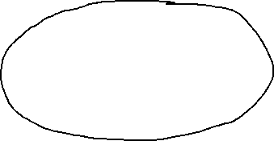

1. The planet will sweep out equal area in the same time interval

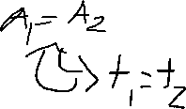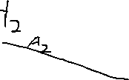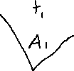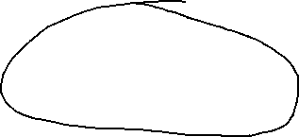

1. The semi-major axis cubed is directly proportional to the period squared of a planet

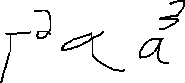

2.4: A satellite orbit has an eccentricity of 0.2 and a semimajor axis of 10,000 km. Find the values of (a) the latus rectum; (b) the minor axis; (c) the distance between foci.

* A) latus rectum
  + e = 0.2
  + a = 10,000
  + LR = 2b^2 / a
  + e^2=1-(b/a)^2
  + 0.2^2=1-(b/10,000)^2
  + b^2=0.96*10,000^2
  + LR = 0.96*10,000^2/a
  + LR = 19,2000 km
* the minor axis
  + b^2=0.96*10,000^2
  + b = 19,595 km
* the distance between foci.
  + c=2ae
  + c=2*10,000,0.2
  + c=4000km

2.5: For the satellite in Prob. 2.4, find the length of the position vector when the true anomaly is 130°.

* r=a(1-e^2)/(1+ecos(theta))
* r=10,000(1-0.2^2)/(1+0.2cos(130))
* r=11,017km

2.6: The orbit for an earth-orbiting satellite has an eccentricity of 0.15 and a semimajor axis of 9000 km. Determine (a) its periodic time; (b) the apogee height; (c) the perigee height. Assume a mean value of 6371 km for the earth’s radius.

* e=0.15
* a=9000
* R_E=6371
* mu=398600
* T=2pi*sqrt(a^3/mu))
  + T=2pi*sqrt(9000/398600)
  + T=7079 seconds
* r_a=a(1+e)
  + r_a=9000(1+0.15)
  + r_a=10350km
  + h_a=r_a-R_e
  + h_a=10350-6371
  + h_a=3979km
* r_p=a(1-e)
  + r_p=9000*1-0.15)
  + r_p=7650km
  + h_p=r_p-R_E
  + h_p=7650-6371
  + h_p=1279km

2.8: The semimajor axis for the orbit of an earth-orbiting satellite is found to be 9500 km. Determine the mean anomaly 10 min after passage of perigee.

* a=9500km
* dt=10*60*600s
* M=n*dt
* n=2pi/T
* T=2pi*sqrt(a^3/mu)
* T=2pi*sqrt(95000/398600)
* T=9274s
* M=2pi(600)/9274
* M=0.406 rad

2.10: Explain what is meant by apogee height and perigee height. The Cosmos 1675 satellite has an apogee height of 39,342 km and a perigee height of 613 km. Determine the semimajor axis and the eccentricity of its orbit. Assume a mean earth radius of 6371 km.

* Apogee height is the furthest point a satellite is away from a point on the surface of the planet. Perigee height is the closest point a satellite is away from a point on the surface of the planet.
* h_a=39342
* h_p=613
* h_a/p=r_a/p-R_E
* r_a/p=h_a/p+R_E
* r_p=6984km
* r_a=45713km
* a=(r_a+r_p)/2
* a=(6984+45713)/2
* a=26348km
* e=r_a/a-1
* a=45713/26348-1
* e=0.735

2.11: The Aussat 1 satellite in geostationary orbit has an apogee height of 35,795 km and a perigee height of 35,779 km. Assuming a value of 6378 km for the earth’s equatorial radius, determine the semimajor axis and the eccentricity of the satellite’s orbit.

* R_E=6378 km
* h_a=35,795 km
* h_p=35,779 km
* r_a/p=h_a/p+R_E
* r_a=42173 km
* r_p=42147 km
* a=(r_a+r_p)/2
* a=(42173+42147)/2
* a=42,165 km
* e=42173 /a-1
* a=42173 /42,165 -1
* e=0.00